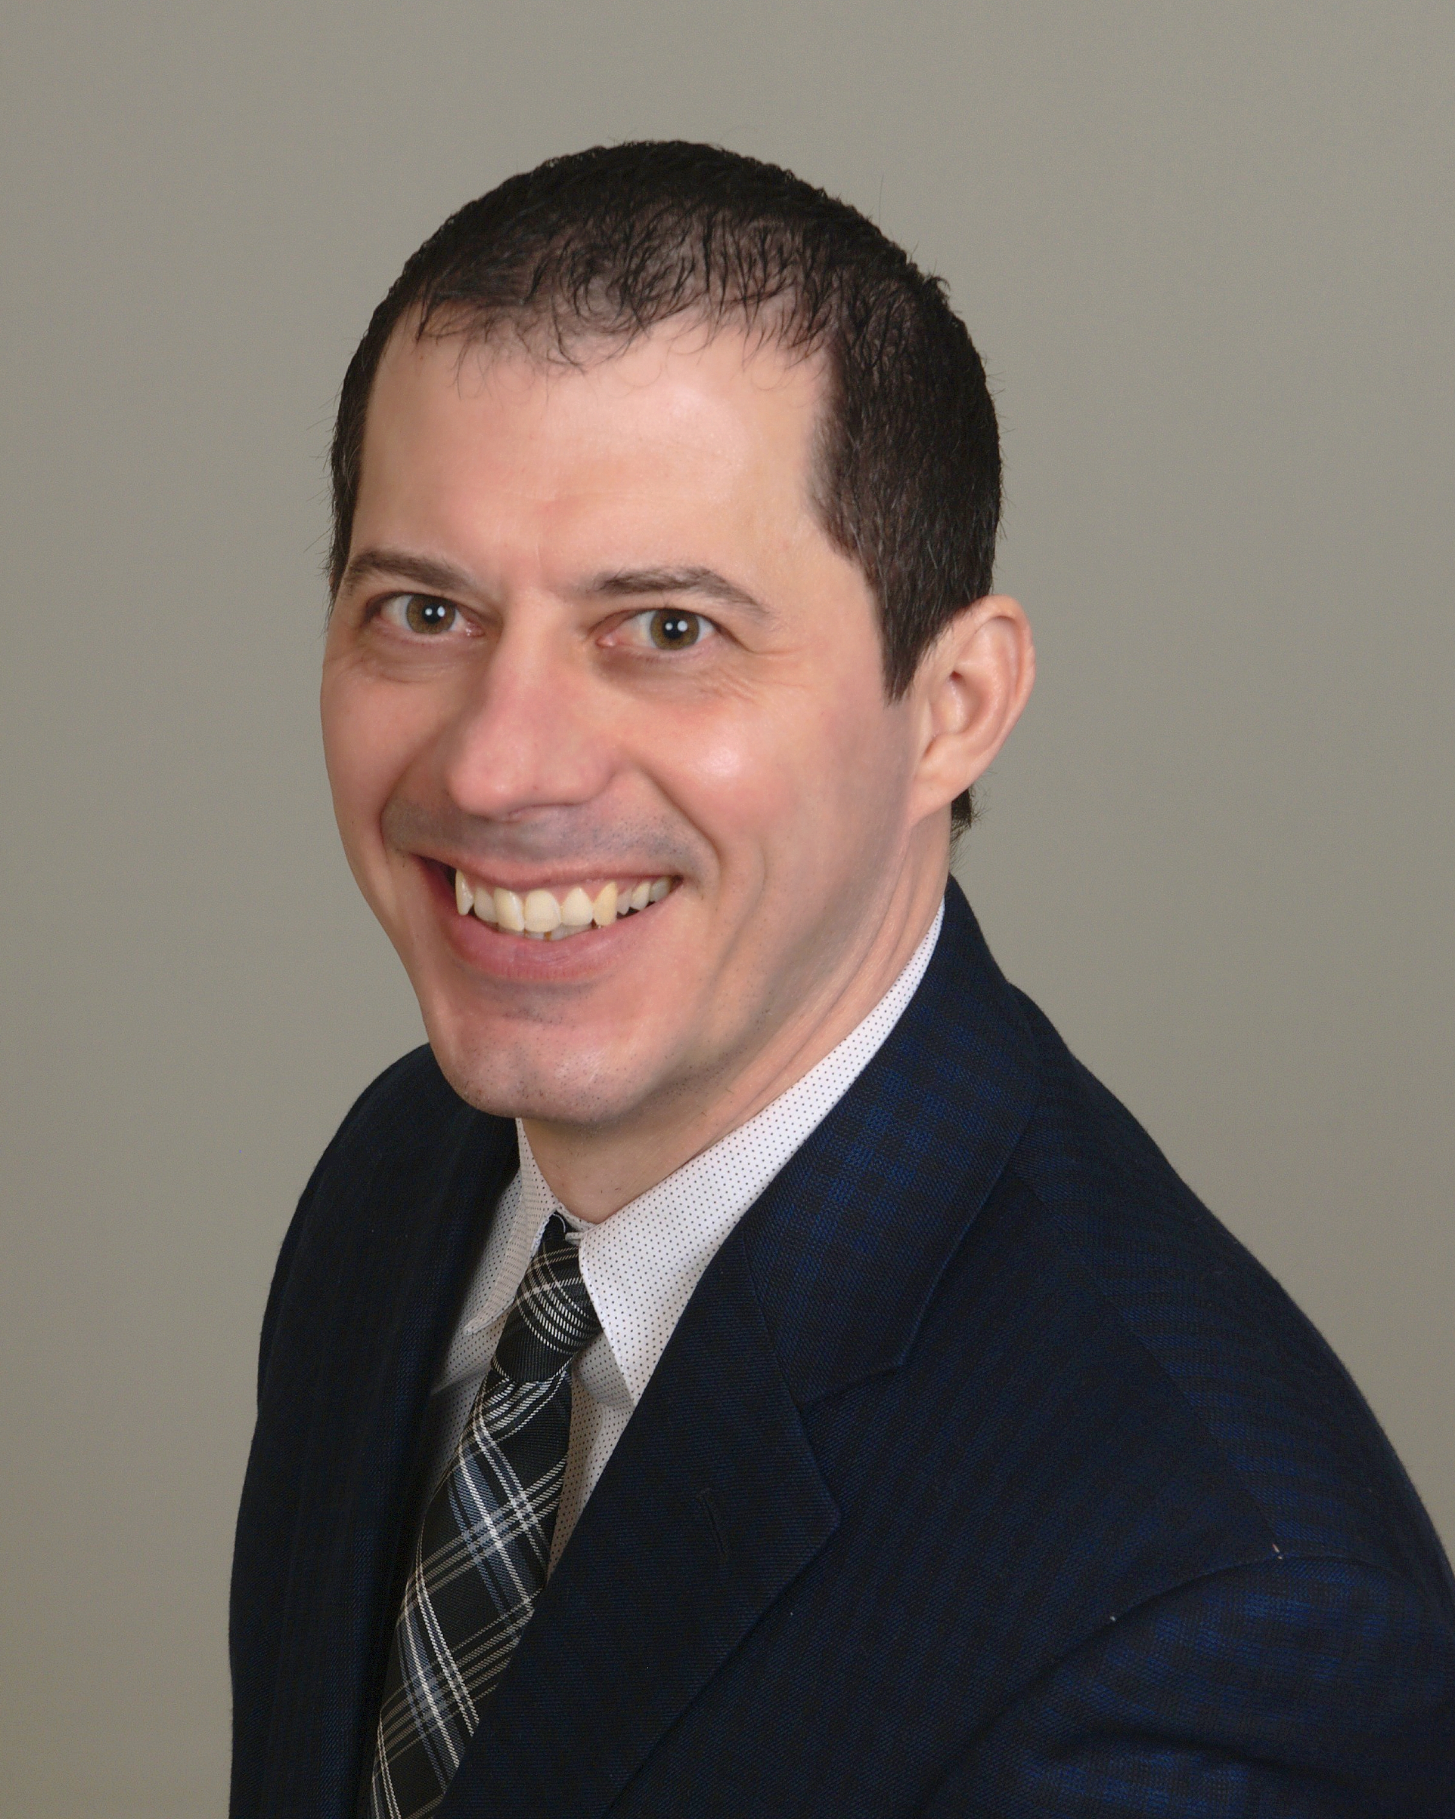 |  |  |  | Joel Campbell Resume  Joel Campbell’s Racing Stable

Experience
2016–Current
• Horse Trainer • Joel Campbell Racing Stable
2013 –2018
Jockey’s Guild Treasurer• • Jockey’s Guild
1999–2016
Jockey• Jockey • Over 1000 Career Wins
I have spent my life dedicated to the Equine Athlete and the Sport of Horse Racing. Being a fourth-generation horseman I value my experience and passion for these animals. I back that up with an Education and a Masters in Equine Management.

Education
Midway University, Midway, KY
- Graduated with a 3.6 GPA

Communication
Joel Campbell Racing Stable values communication with its clients. We value customer service and complete transparency. This why I believe I stand a part and welcome communication, honesty, integrity, and most of all a winning attitude.

Leadership
Leadership is the key to a successful operation and our stable is no different. We hire people who are responsible as well as passionate about the horses in are care. We possess a team atmosphere where everyone has a say, but decisions are made by what is best for the animal’s in are stable.

References
[Available upon request.]
23144 N Lakewood Ln
Lake Zurich, IL 60047
 |  | 847-372-6276
 |  | joelcampbellracingstable@gmail.com
 |  | www.joelcampbellracingstable.com

